**3-Tier Architecture**

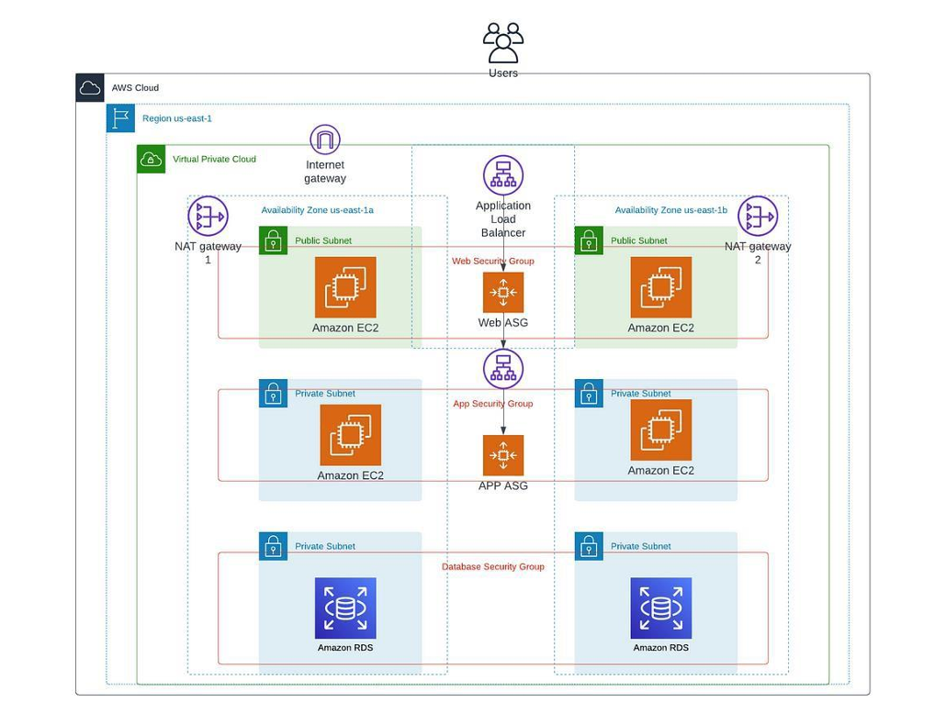

In this architecture we are going to create web-tier,app-tier,db-tier.

First we new to create vpc ,subnets,internet gateway,route table , nat gateway.

Go to vpc click on create vpc.

Creation of vpc we have to option

Vpc only and vpc and more .

If we use vpc and more it automatically create the subnets, internet gateway, route table, and nat gateway.

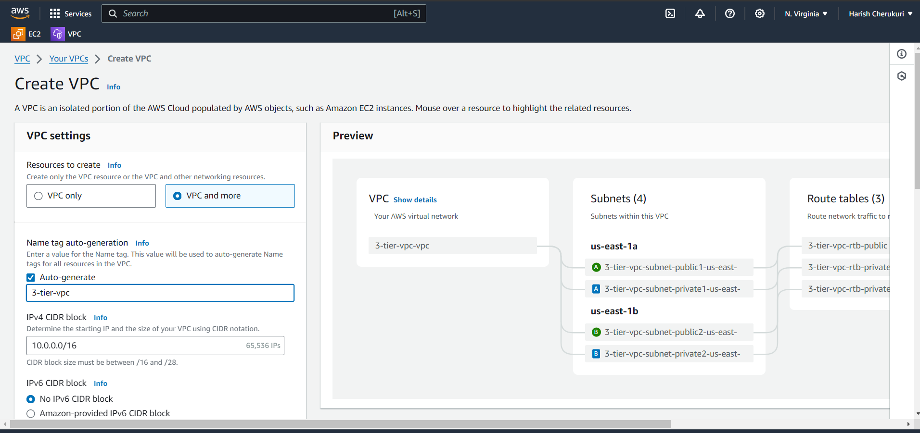

Give vpc name select the how many public subnets and private subnets.

After selecting over click on create vpc .

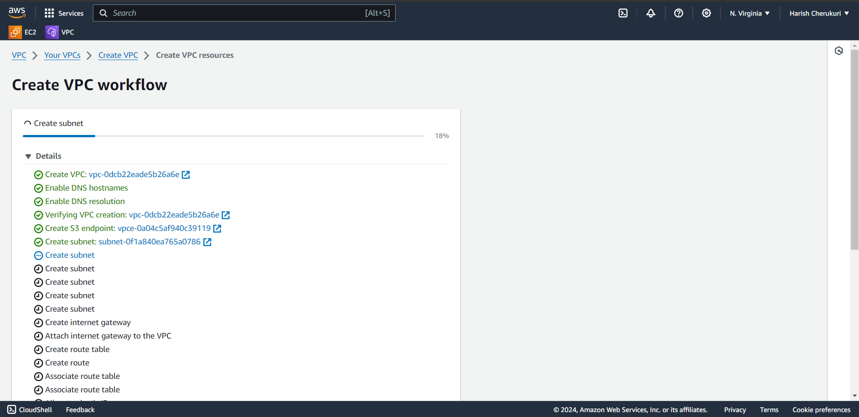

It will create like this.

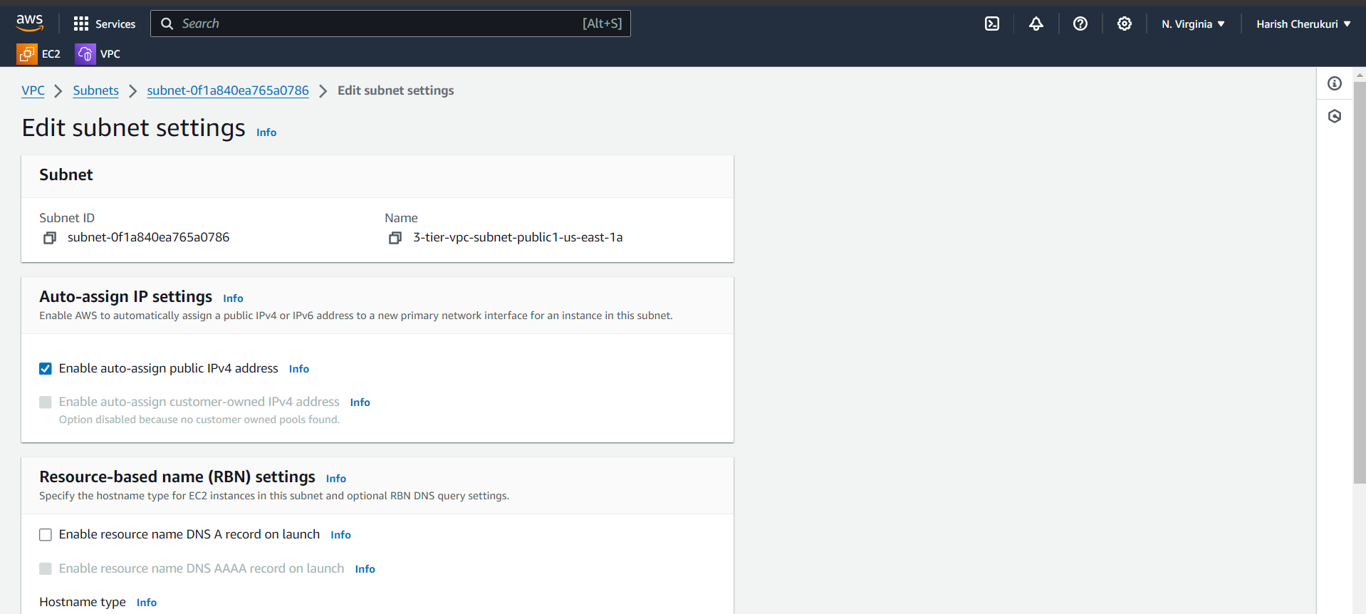

Now go to every subnet enable the “auto-assgin public address”.

After updateing the every subnet go to ec2 .

**1.web-tier**

Create two ec2 instance in public subnet.

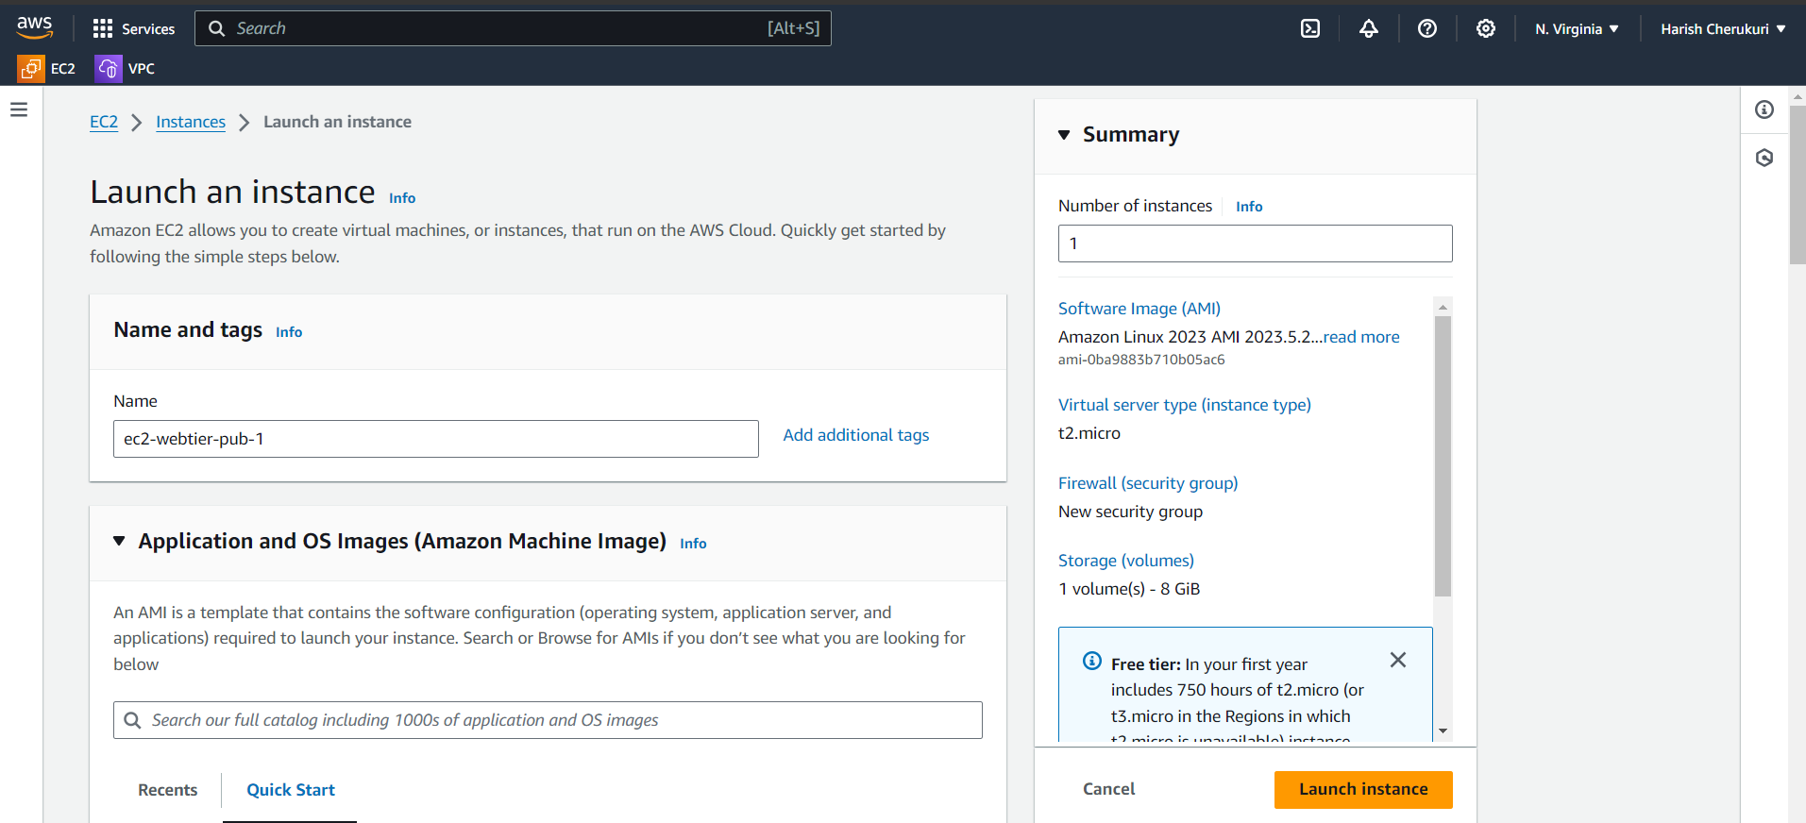

Gice the instance name as ec2-webtier-pub-1.

Select the ami as amazon linux.

Give the kay pair.

Expand the networks select the vpc and public subnet 1.

Create the security group.

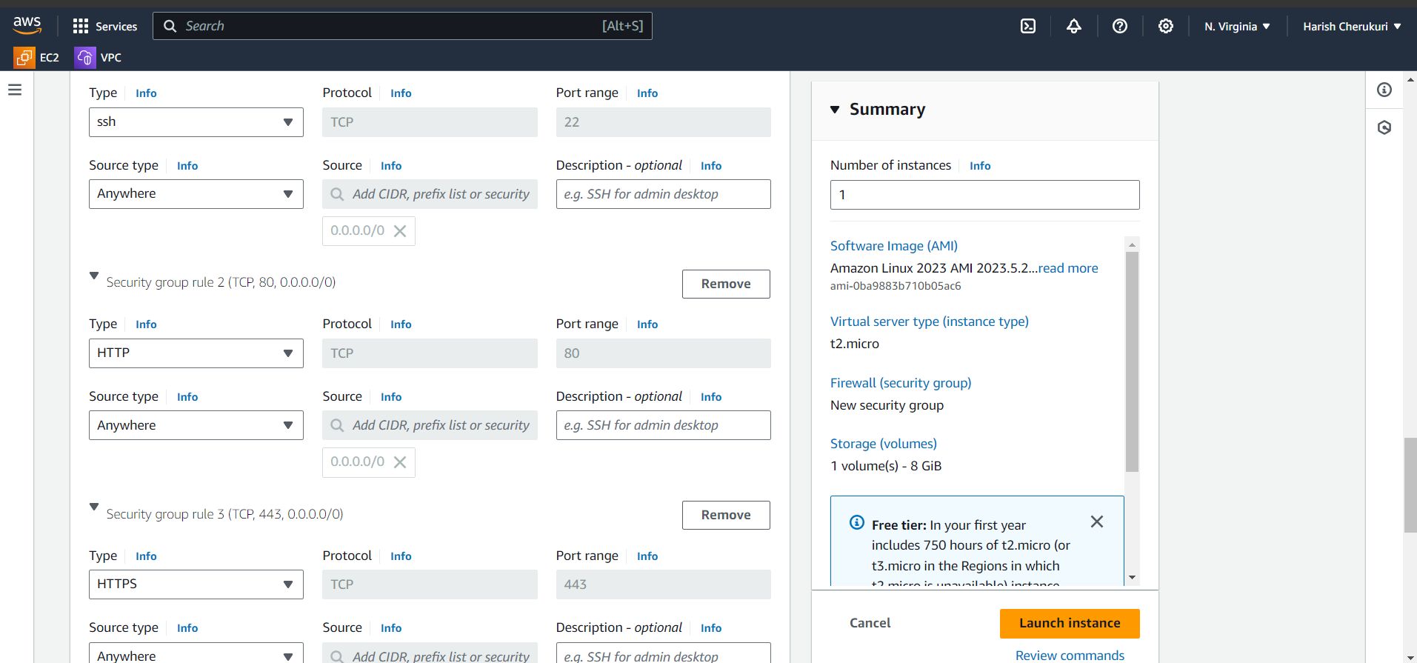

In security group allow the security ports.

Ssh,HTTP,HTTPS.

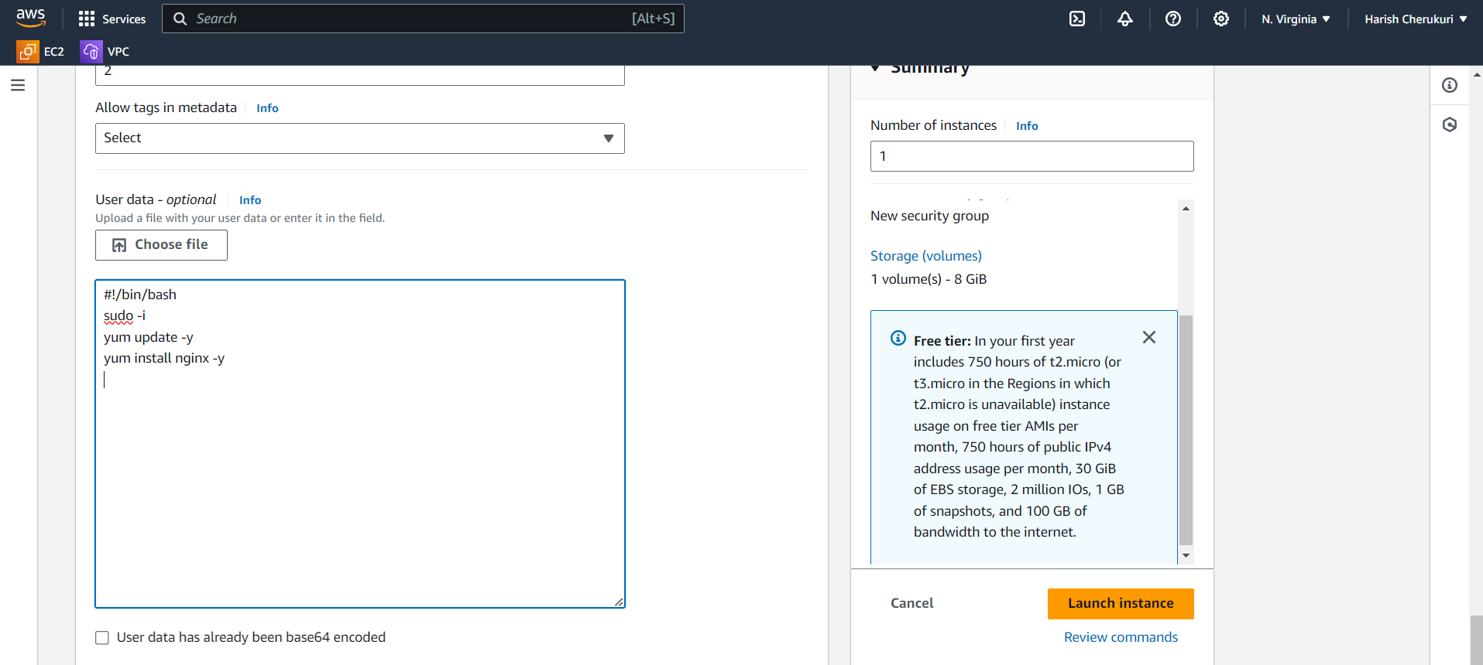

Give user data when you launch the instance it automatically nginx also installed.

Click on launch instance.

Create another instance .

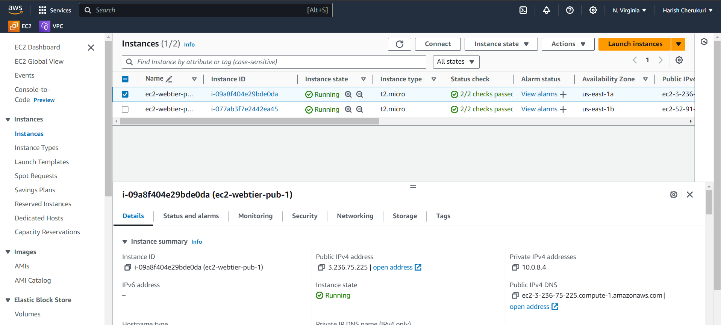

Two instance is created.

Check the nginx is running are not.

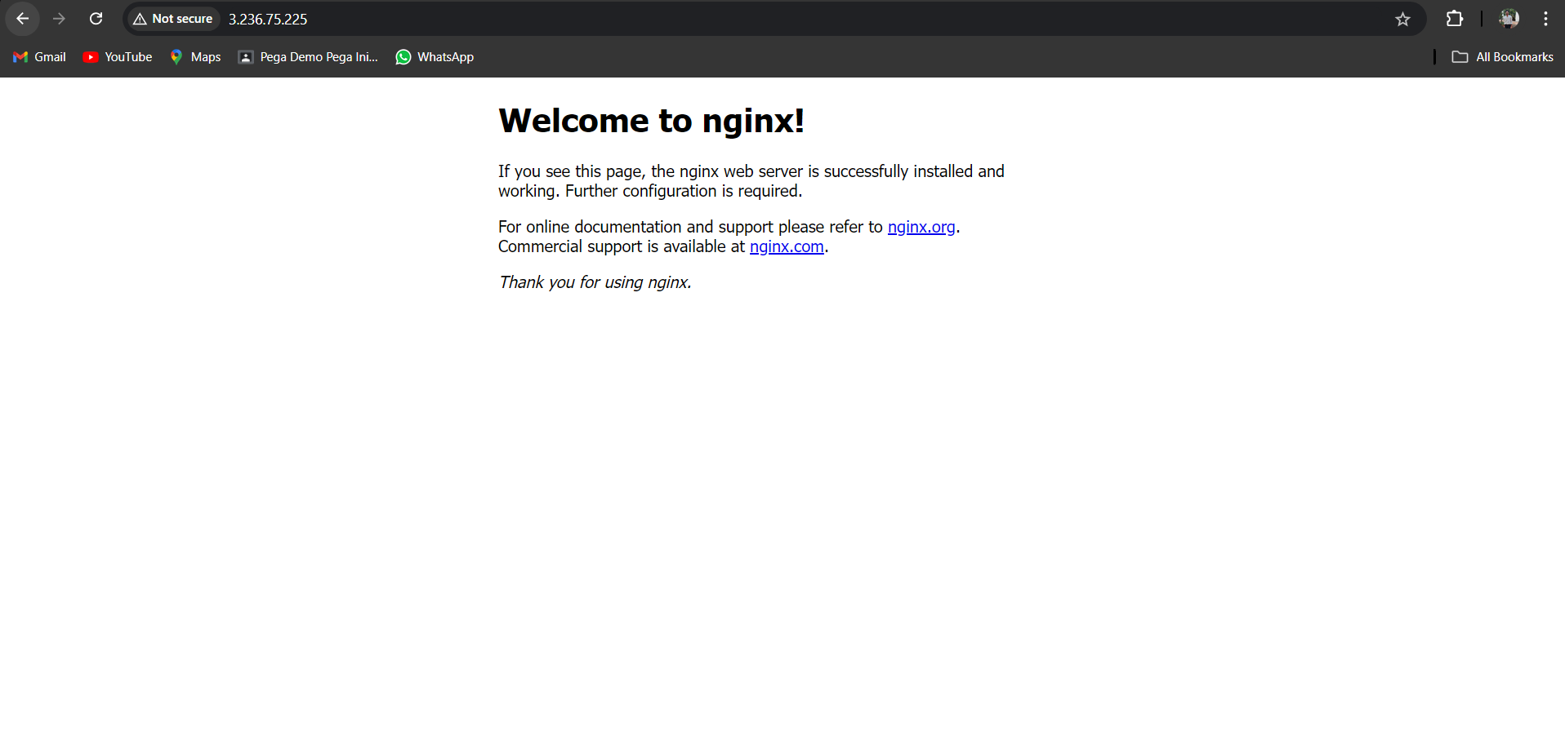

Successfully nginx is running.

Now create the load balancer.

First we need to target group to create load balaner.

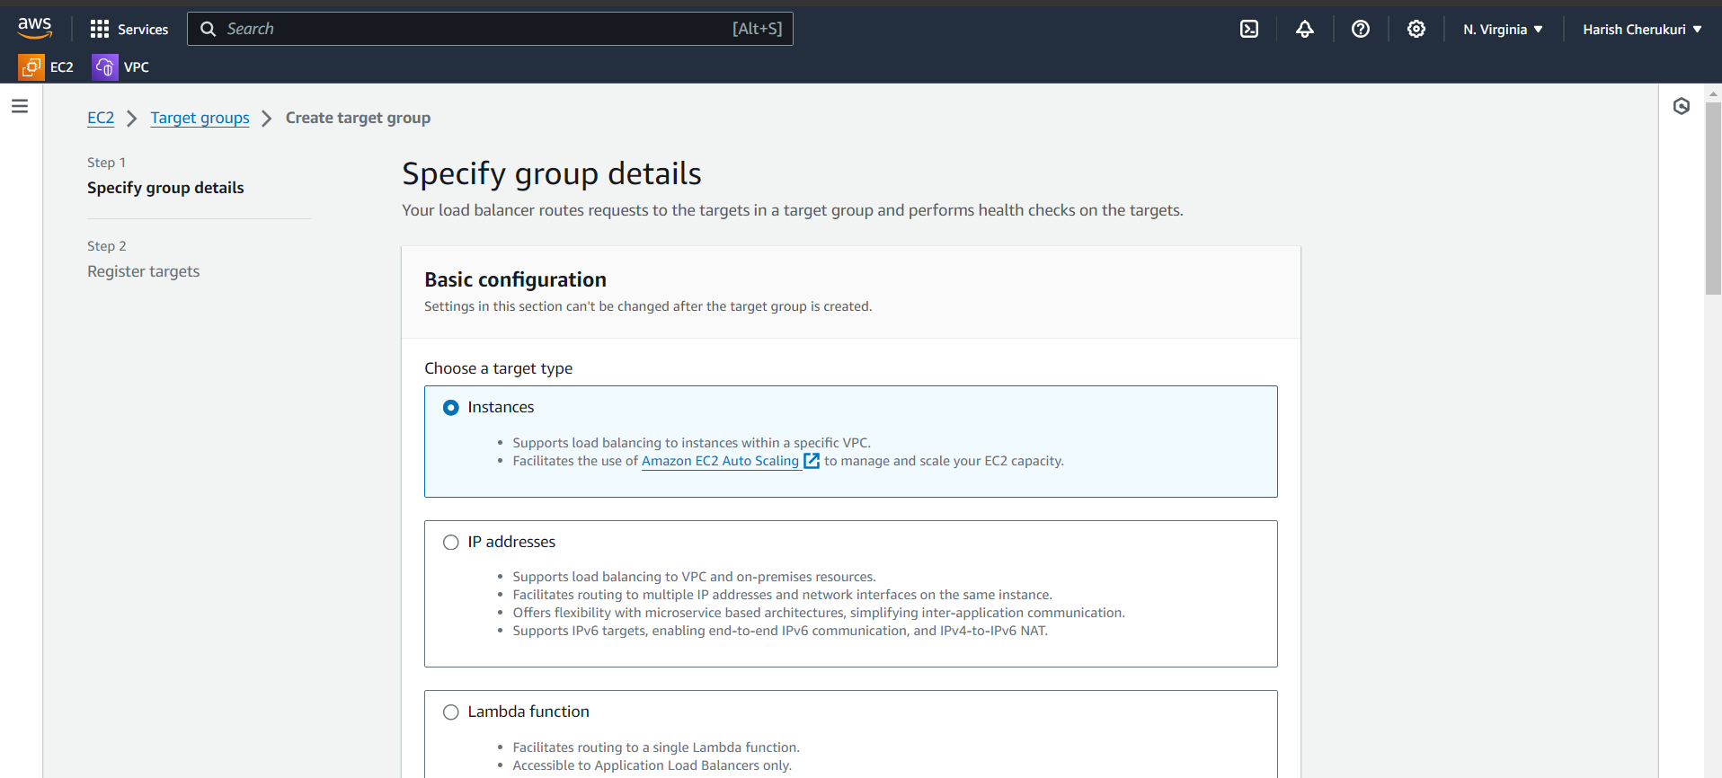

Select the instance give the target group name and also select the vpc.

Click on next .

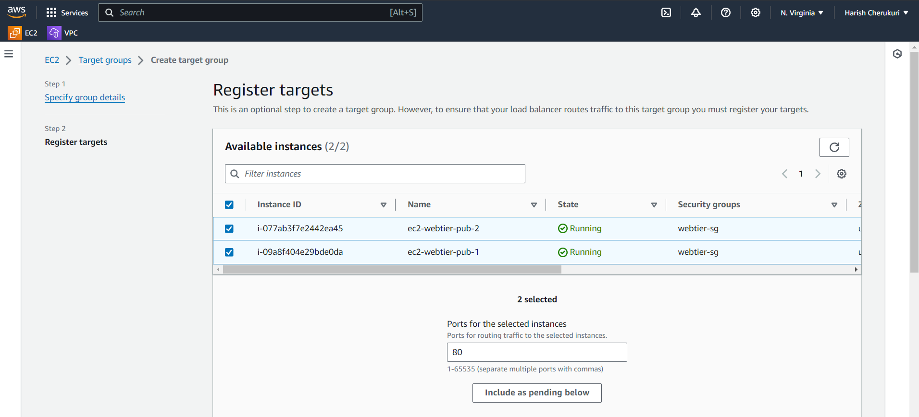

Select the which instance we are going to targeting .

Must select the include as pending below.

Now create load balancer.

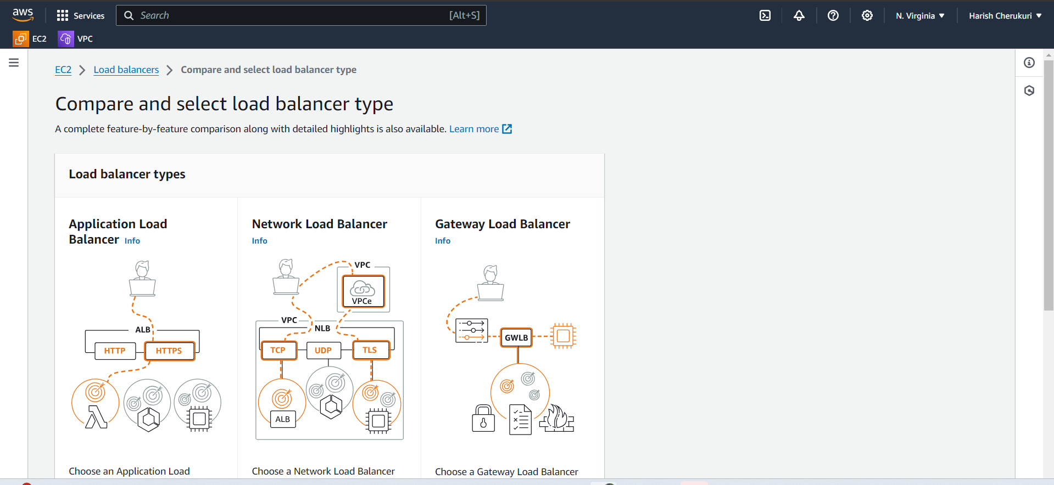

Use application lb.

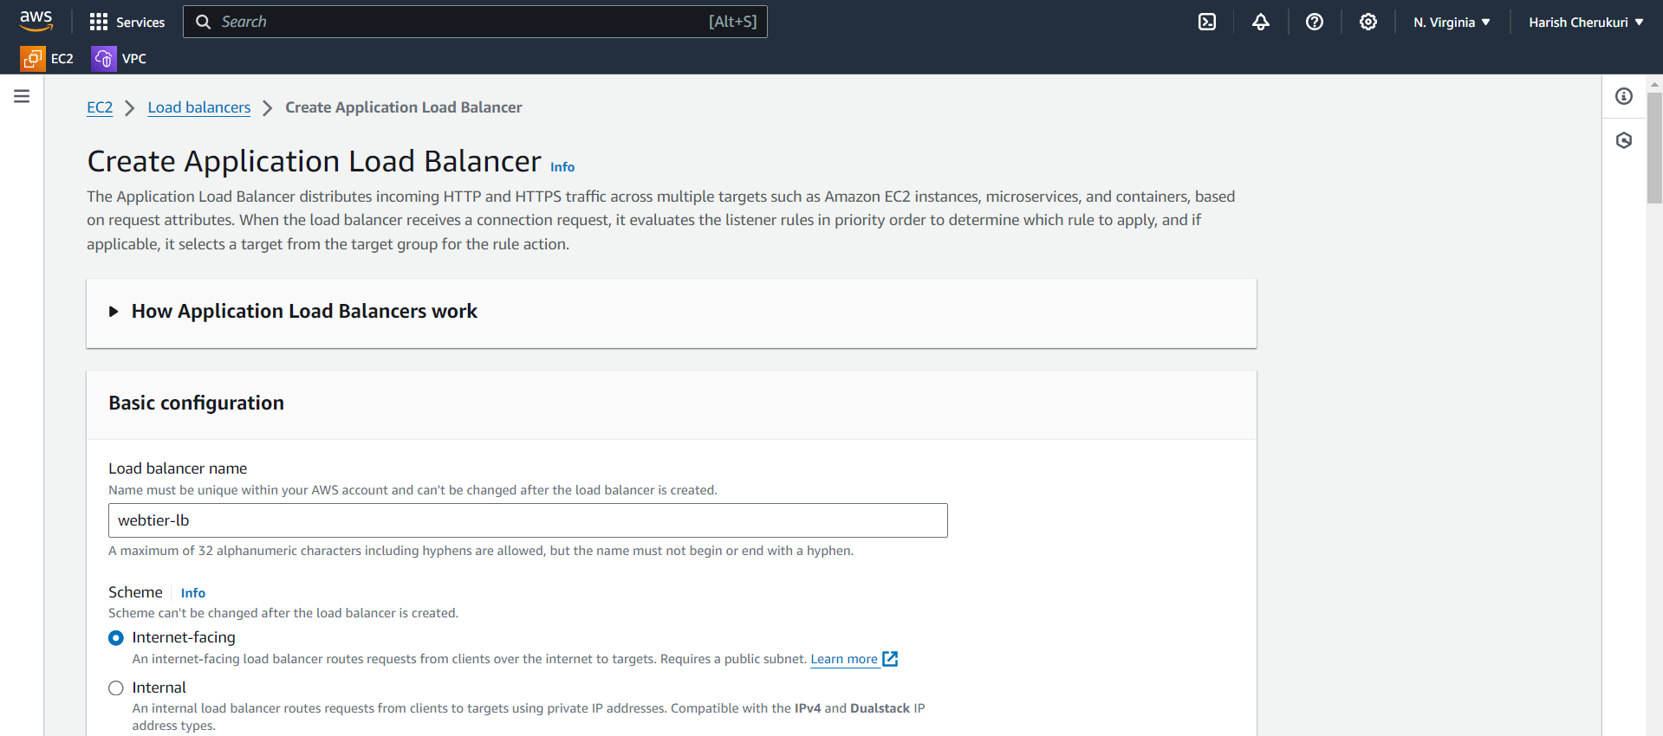

Give lb name and select the internet facing

Select the vpc and subnets,security group.

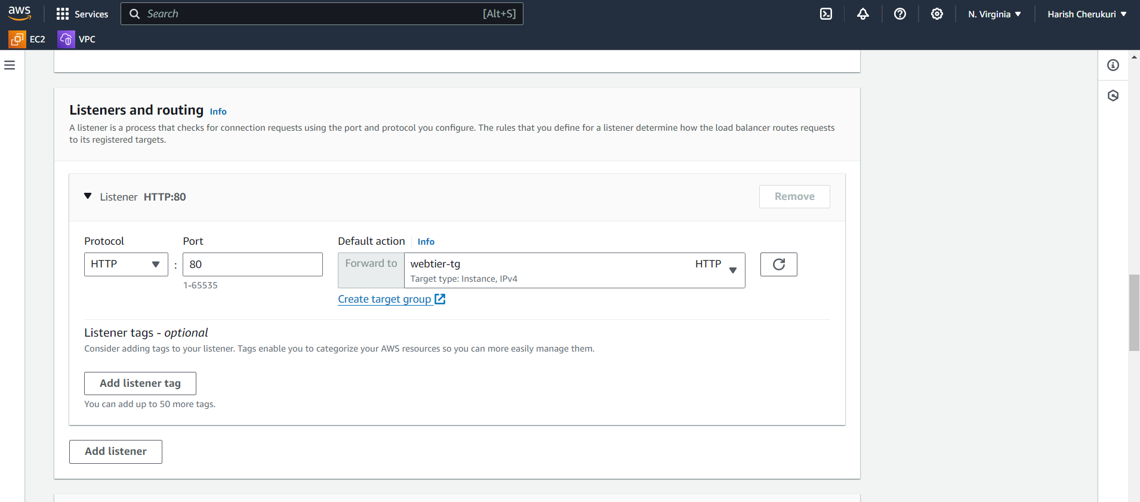

Select the target group.

Click on create lb.

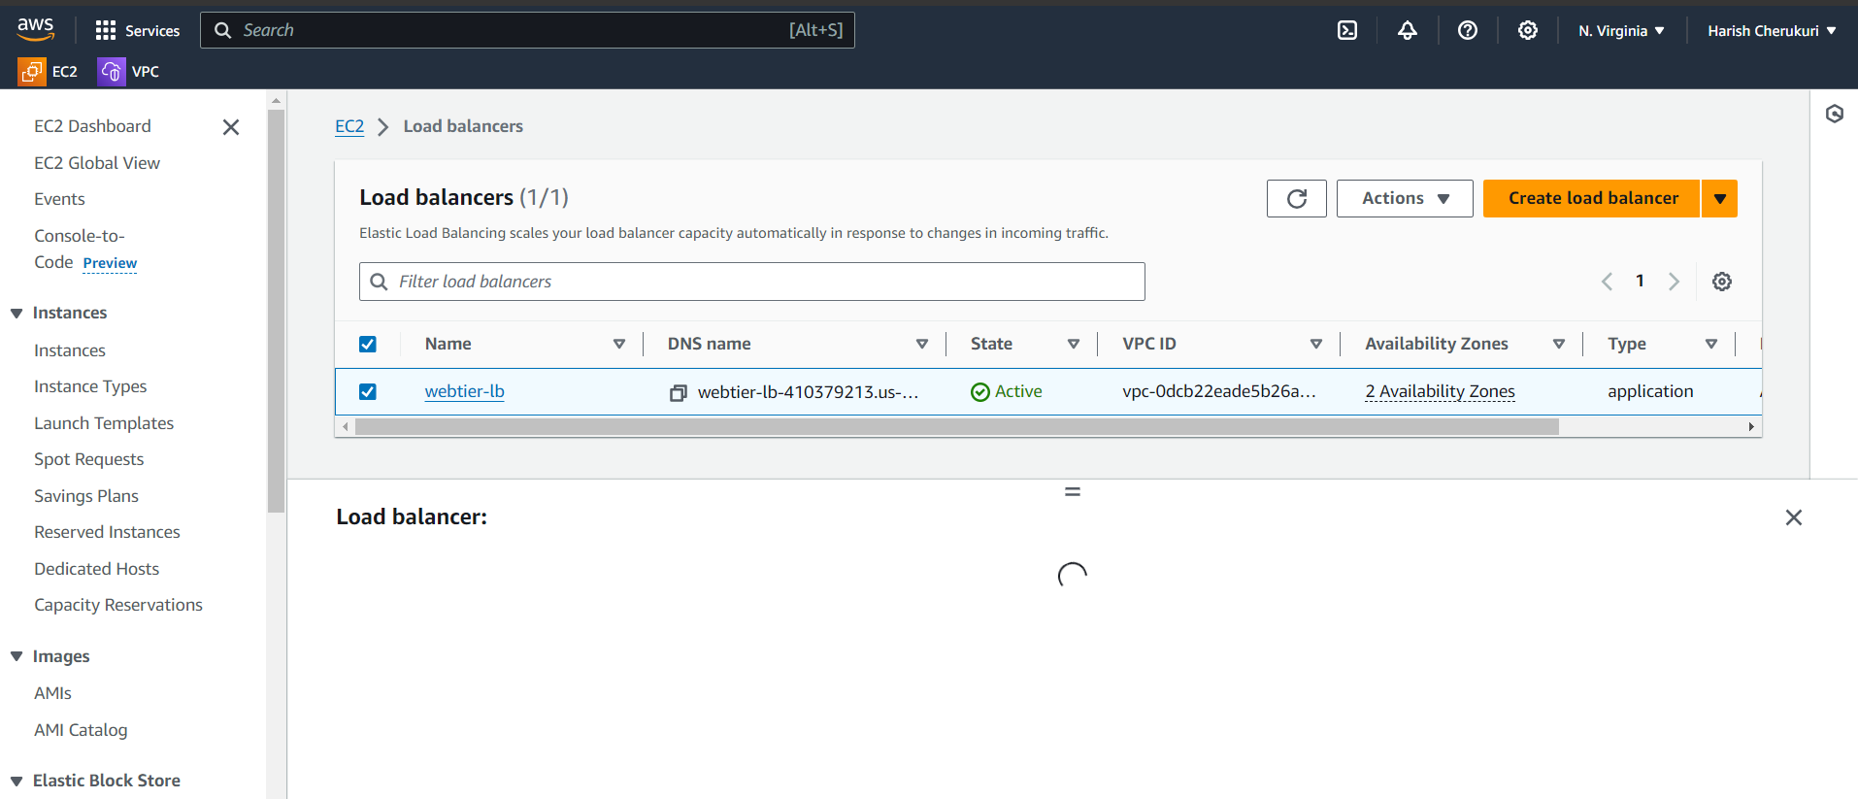

Lb is created.

Now launch the tamplate for auto scaling.

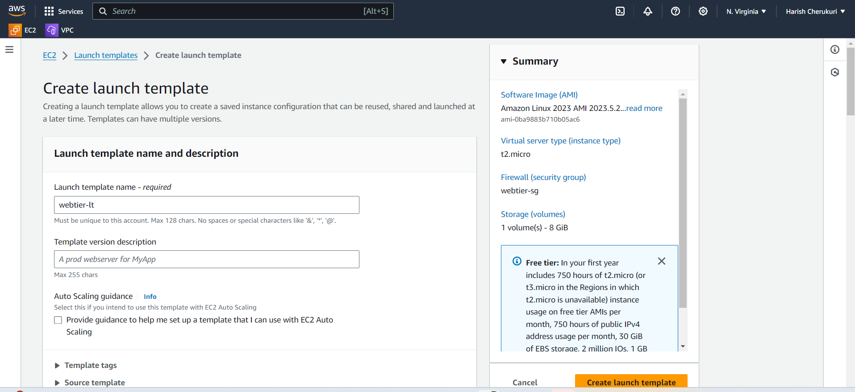

Give the launch tamplate name.

Select the ami and instance type,key pair,security group.

Click on launch tamplate.

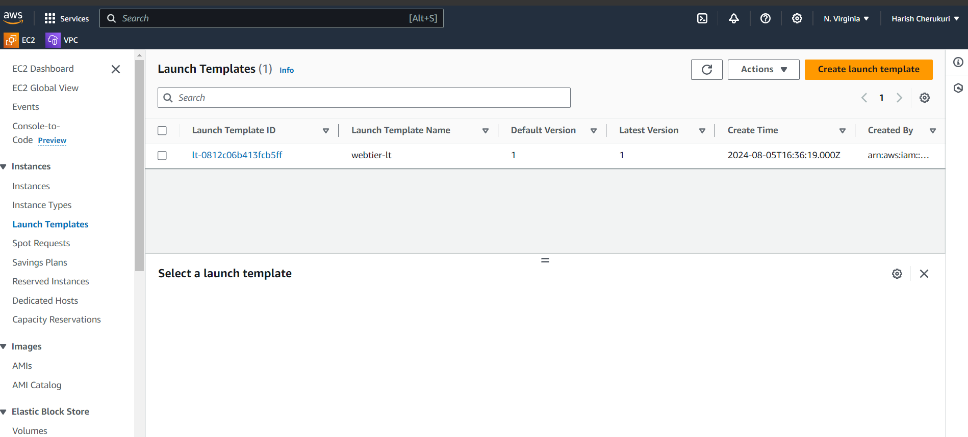

Launch tamplate is created

Now create auto scaling group.

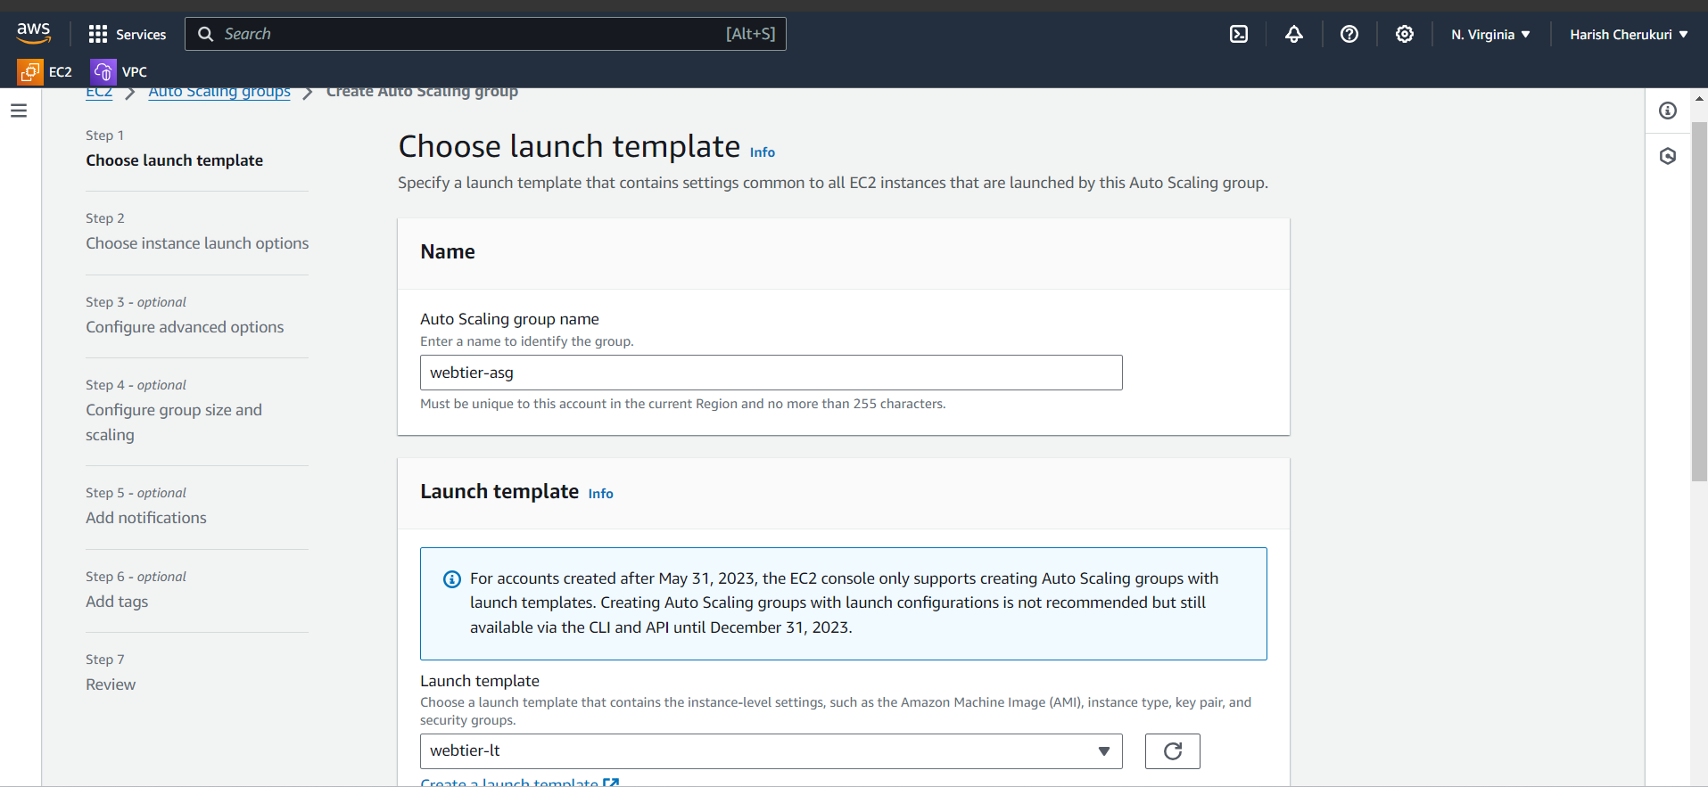

Give the asg name and select the launch tamplate .

Click on next.

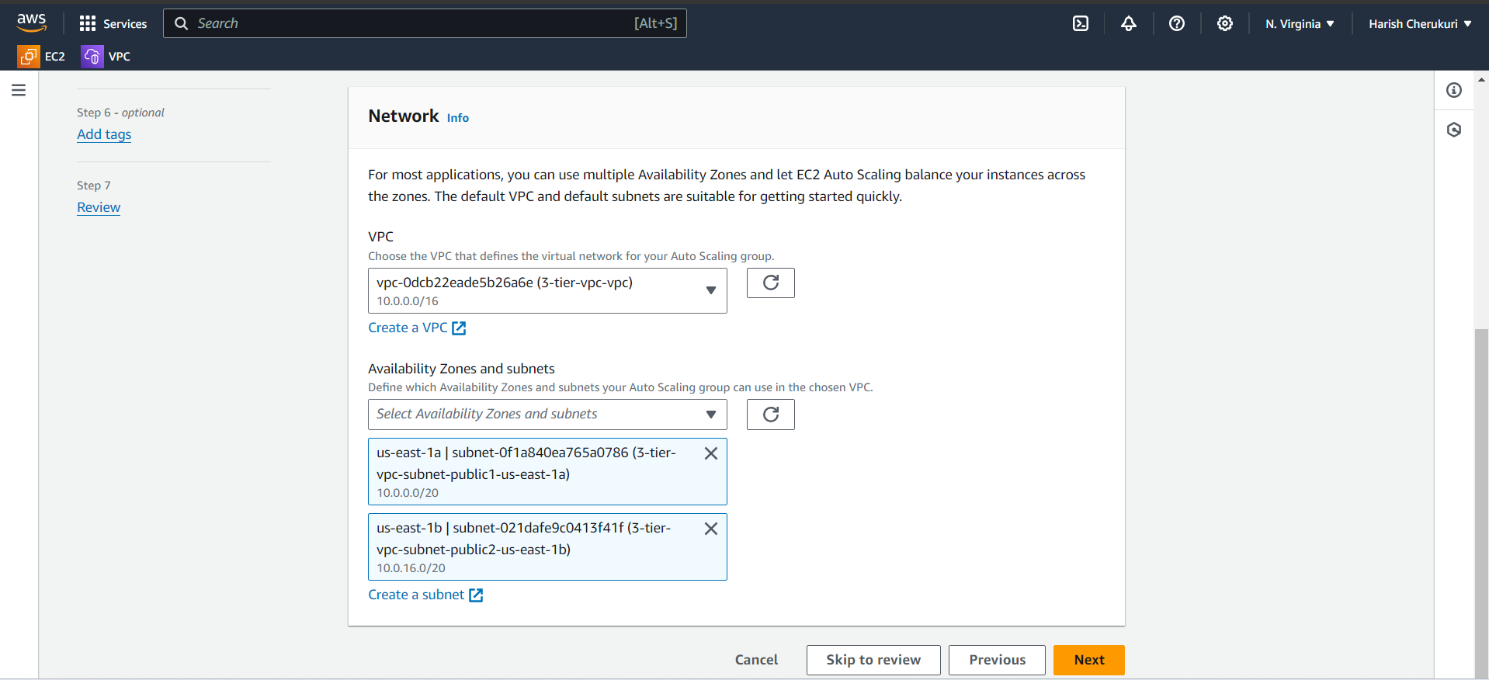

In network select the vpc and subnets click on next.

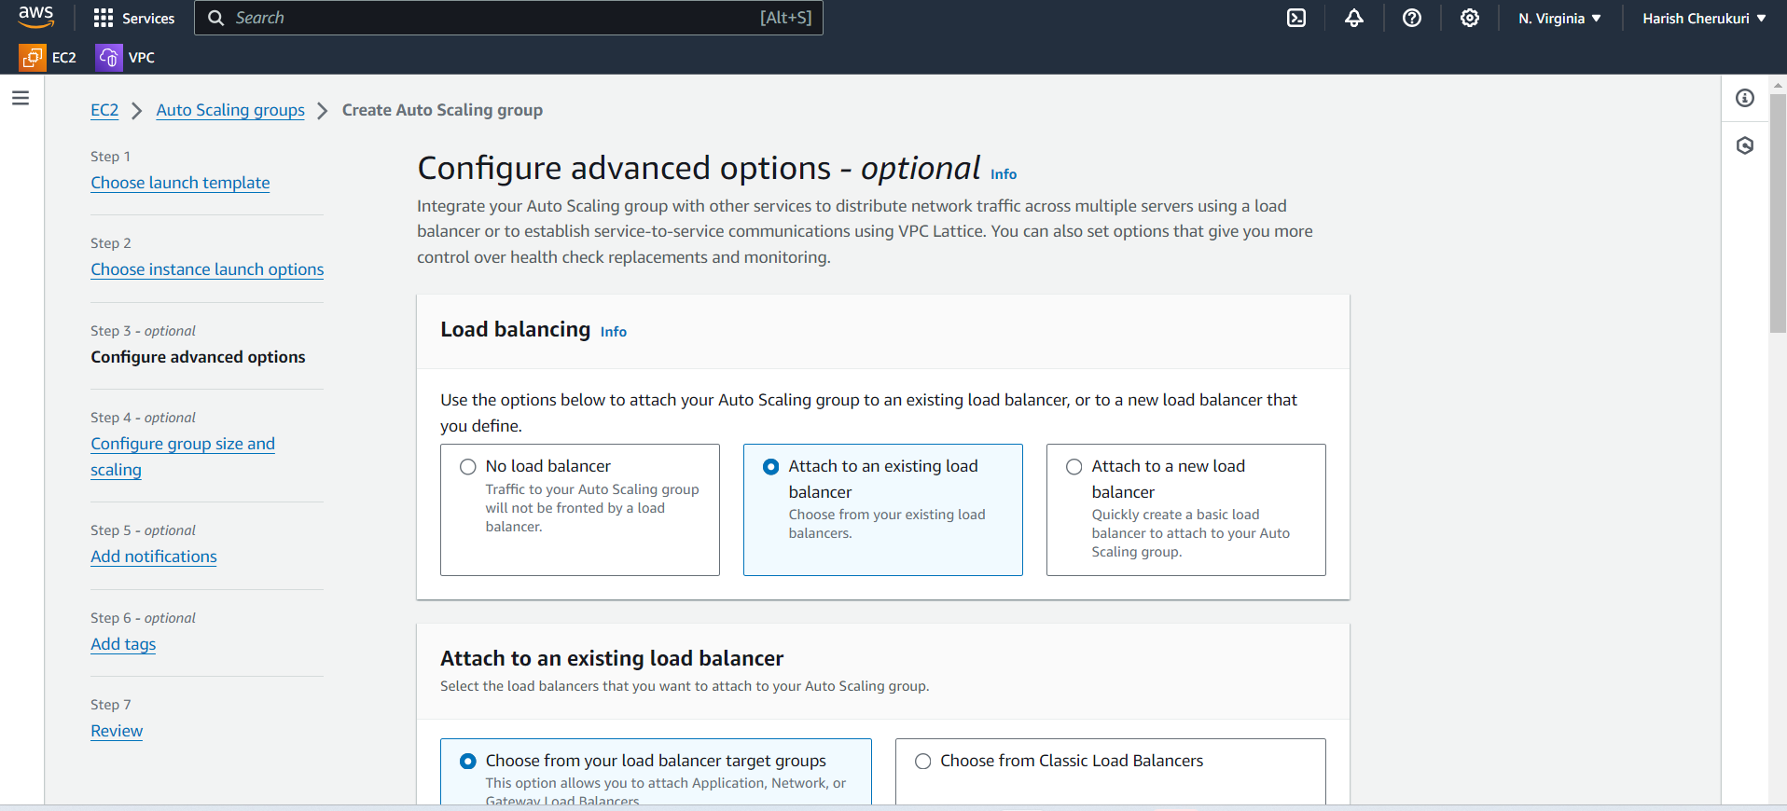

Select the attach to an existing lb select the lb target group.

Click on next.

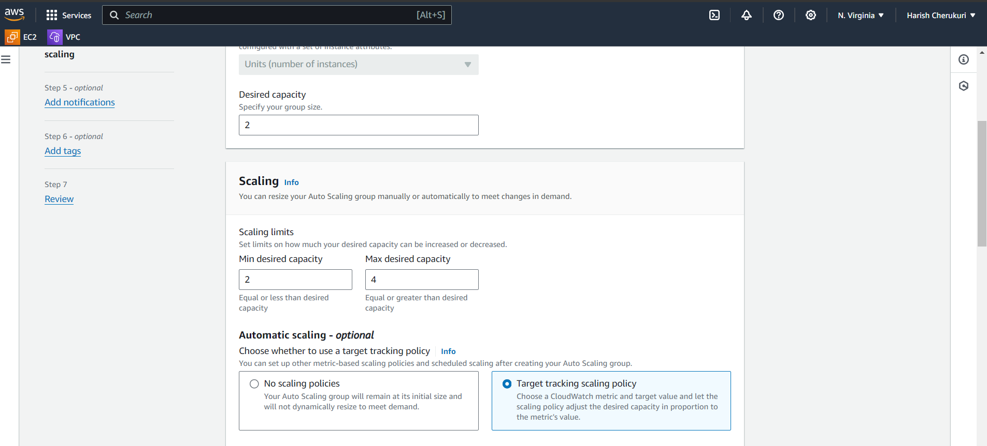

Select the desired capacity and max capacity.

Select the target tracking scaling policy.

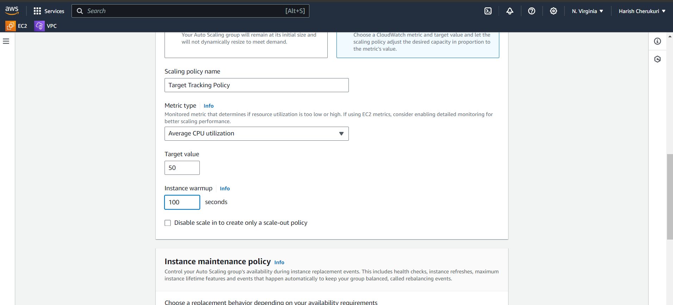

Give the cup target value.

Click on next .

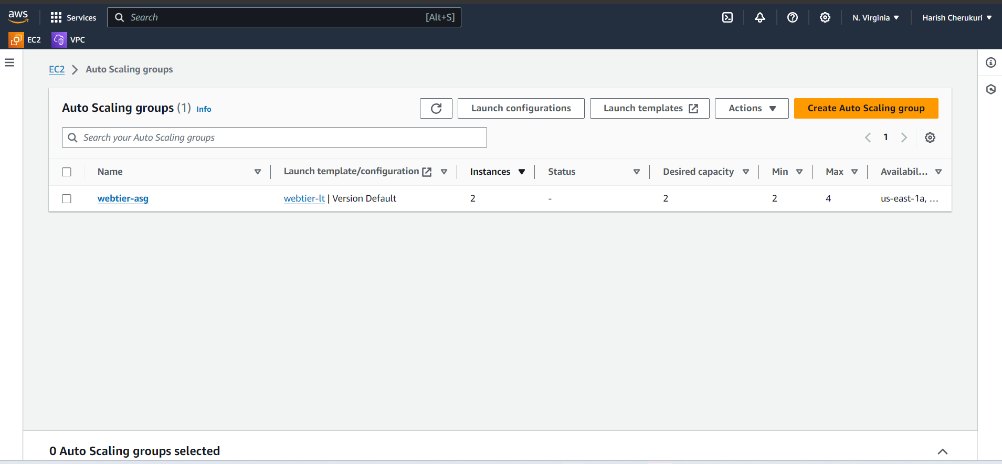

Asg also created.

Now copy the DNS of lb paste it on brower.

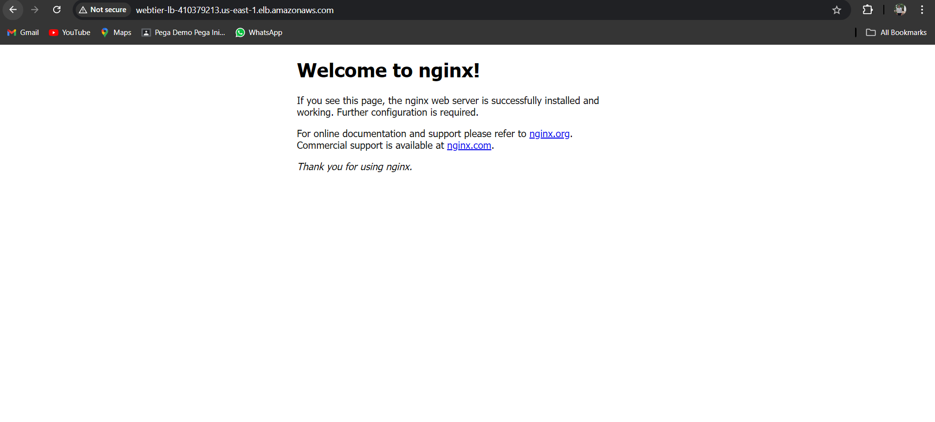

Running.

Web-tier is completed.

Now its time to create app-tier.

**2. App-tier**

First we want to create the instance in private subnet .

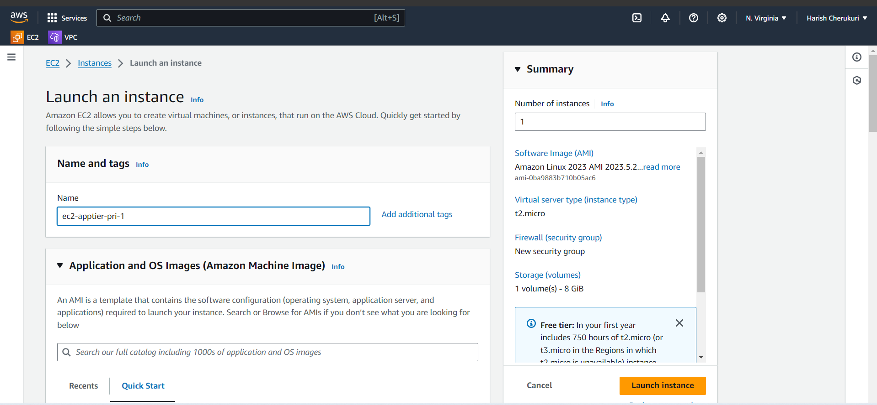

Give the ec2 name .

Select the ami and instance type,key pair.

Create new security group for app tier.

Create another instance in az-1b.

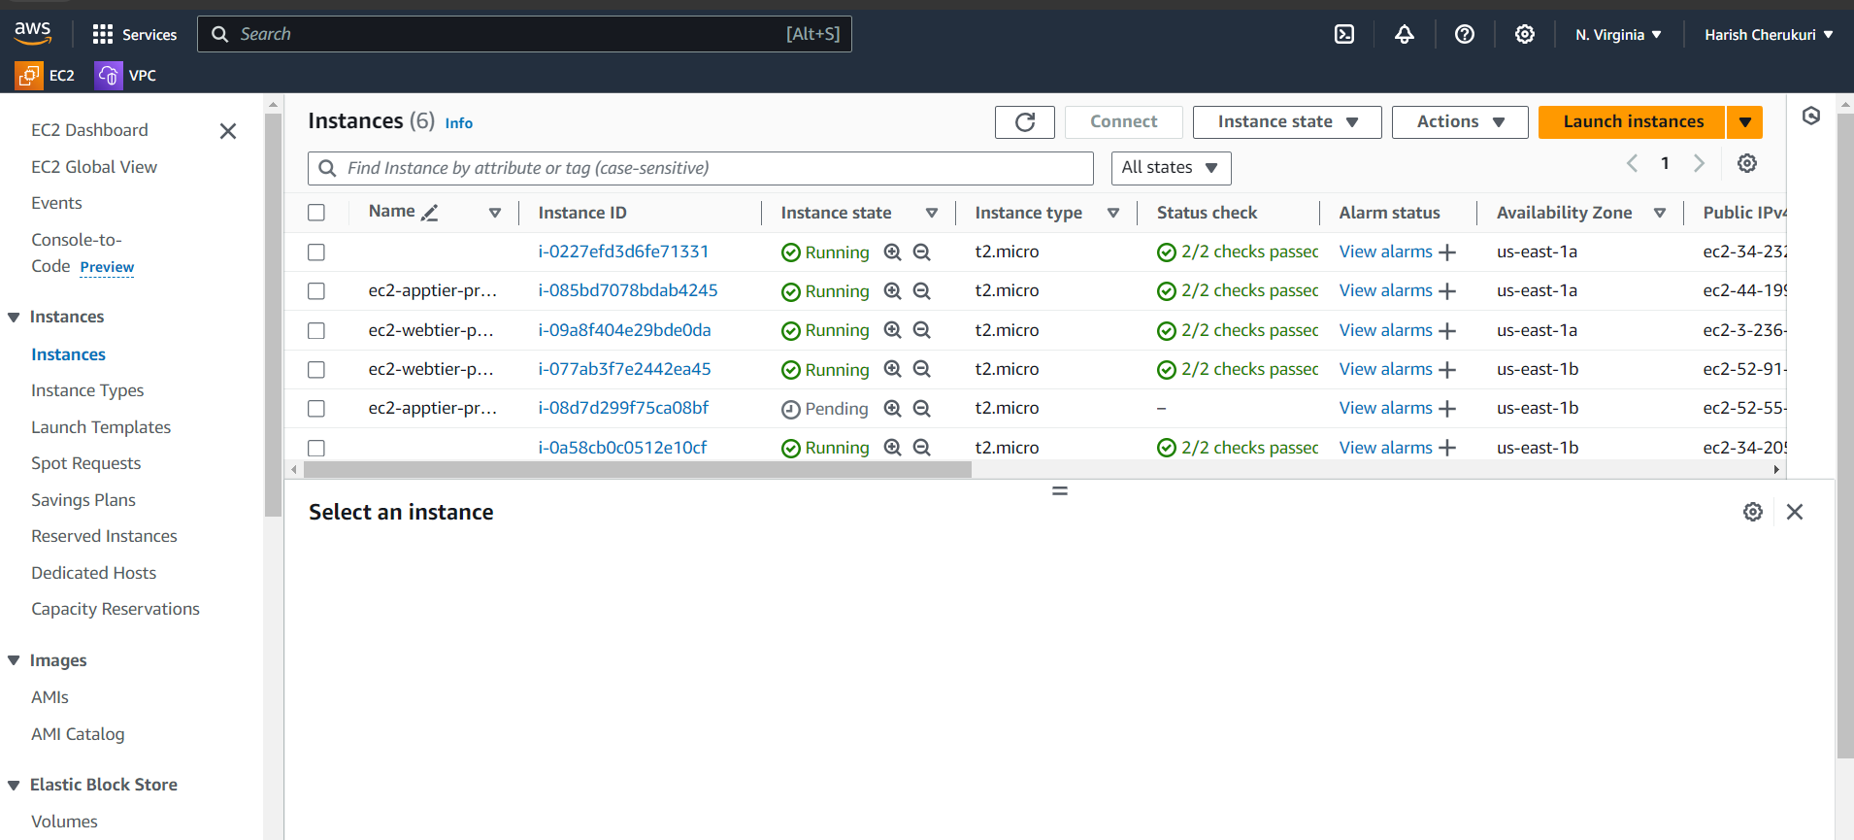

Both instance are created.

Now create launch tamplate.

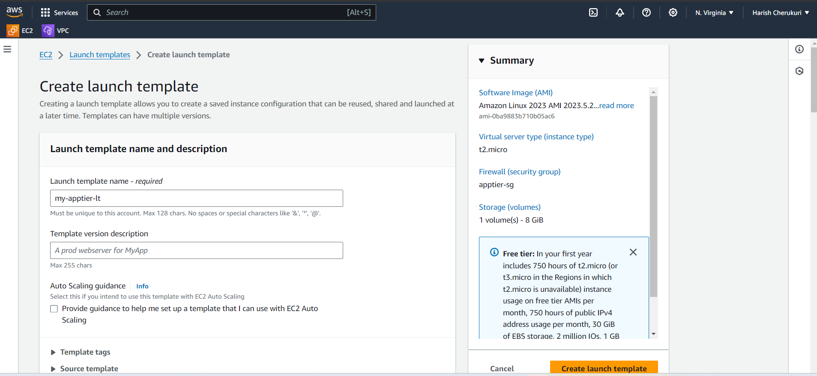

Give the name select the ami,key pair,instance type, security group.

Create launch tamplate.

Now create lb for app-tier instance.

To create lb first we need target group.

So create target group.

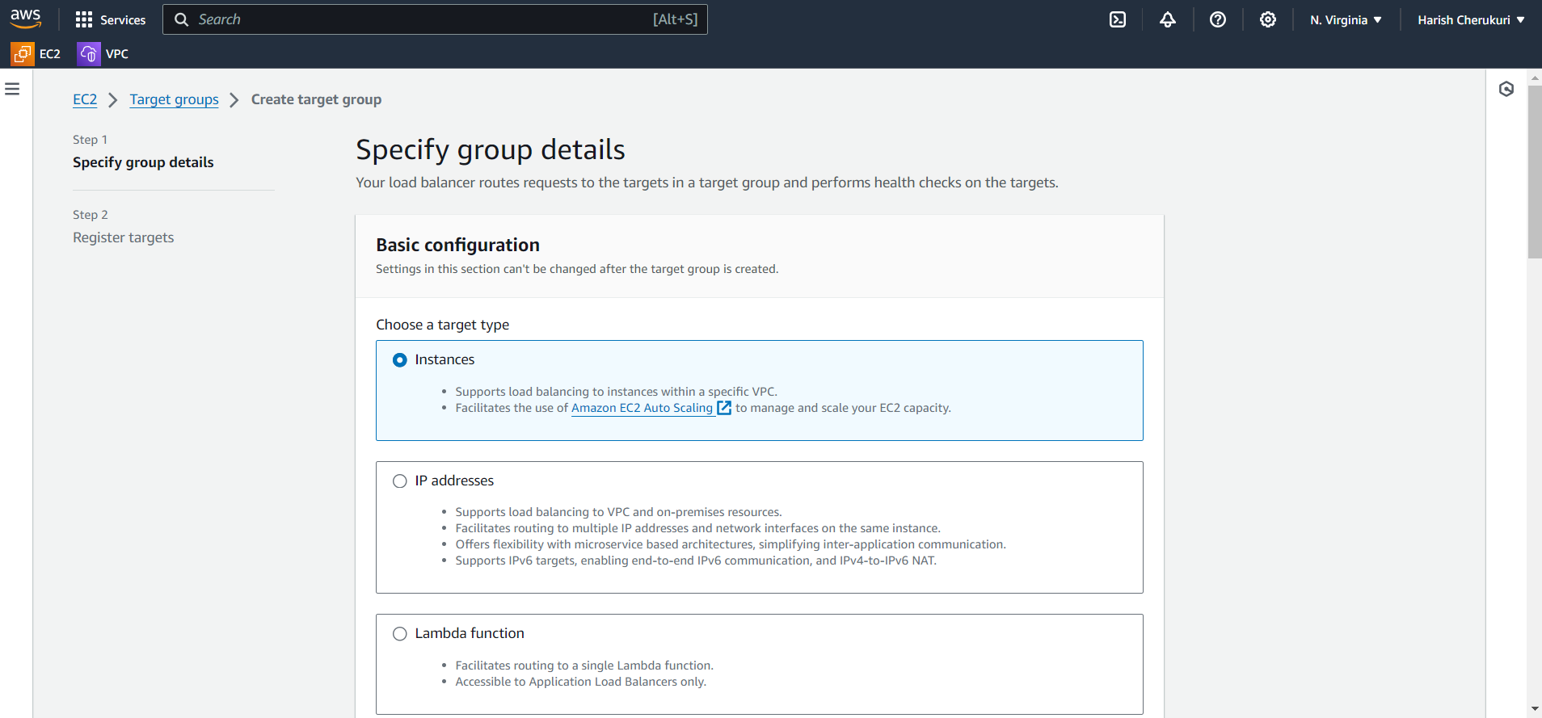

Give tg name and select the vpc .

Click on next.

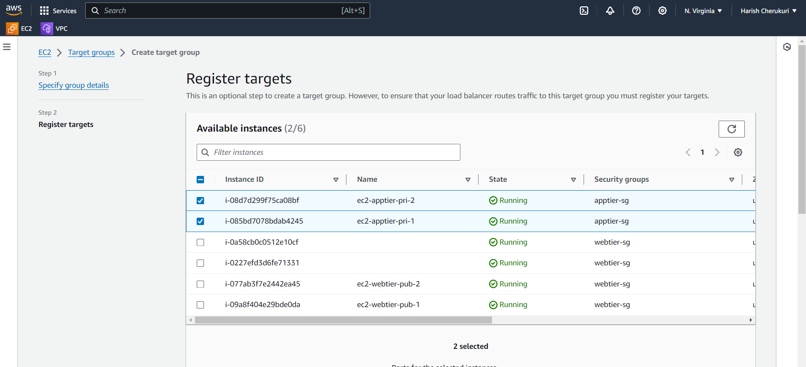

Select the which instance are going to targeting.

Create tg.

Now create the lb.

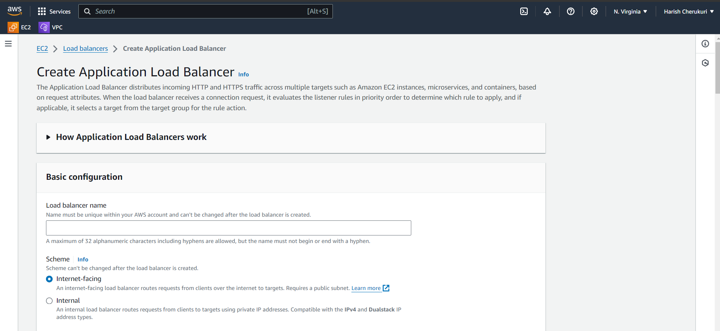

Give the lb name select the subnets,select the target group.

Create lb.

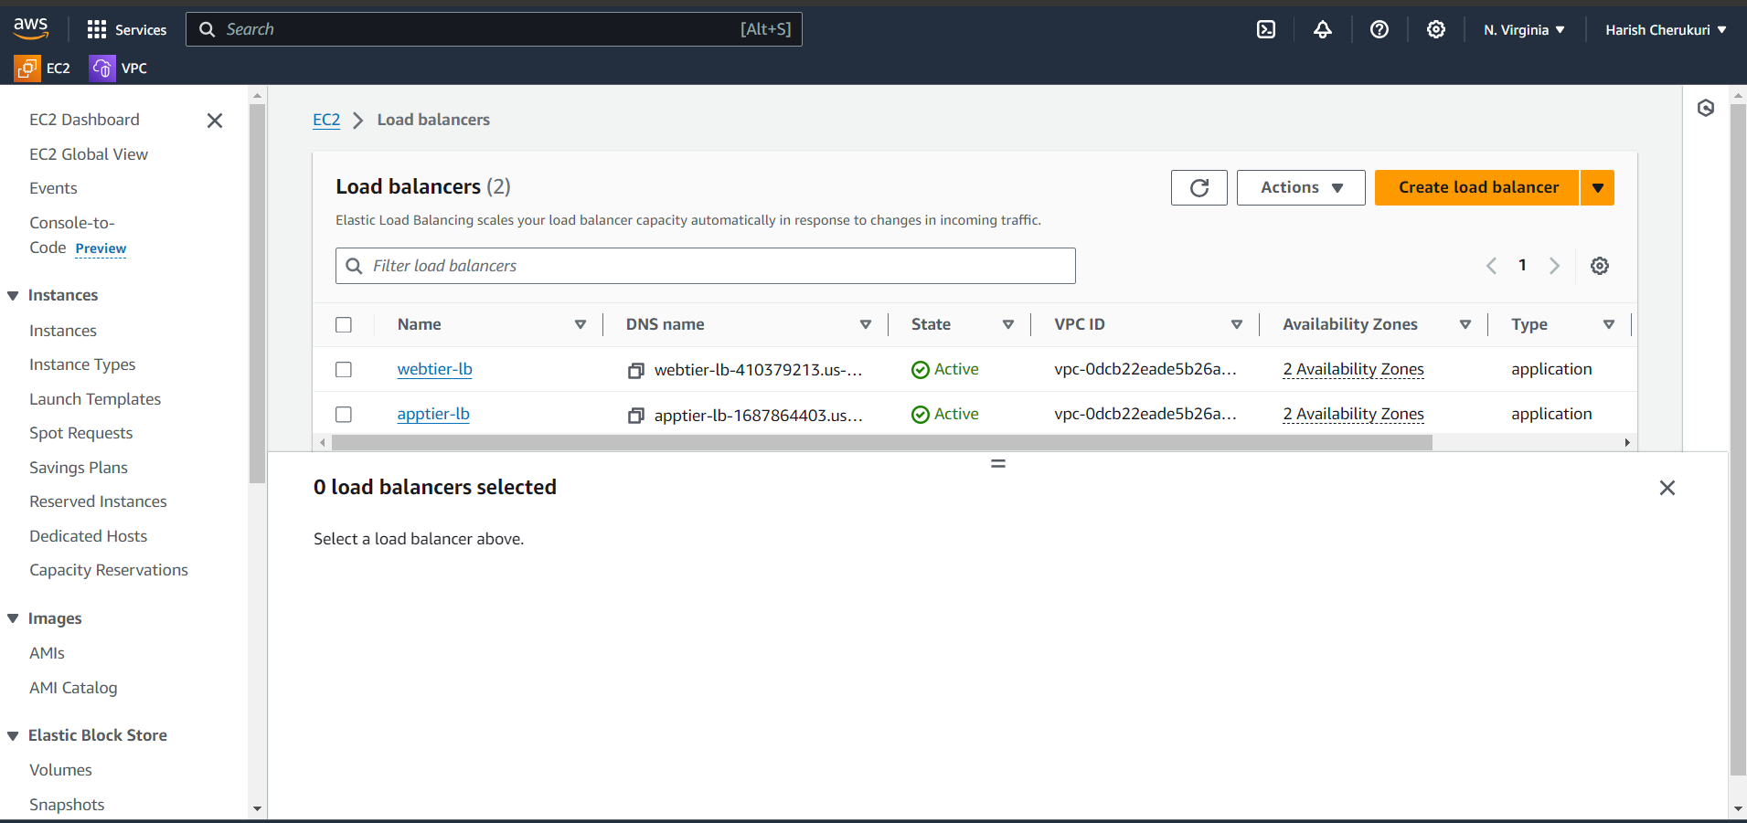

Lb is created.

Now create the asg.

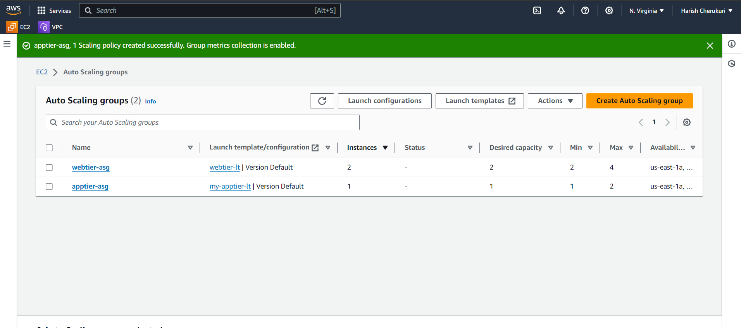

App-tier asg is created.

Now testing time using ping ip address of private instance in public ec2 instance.

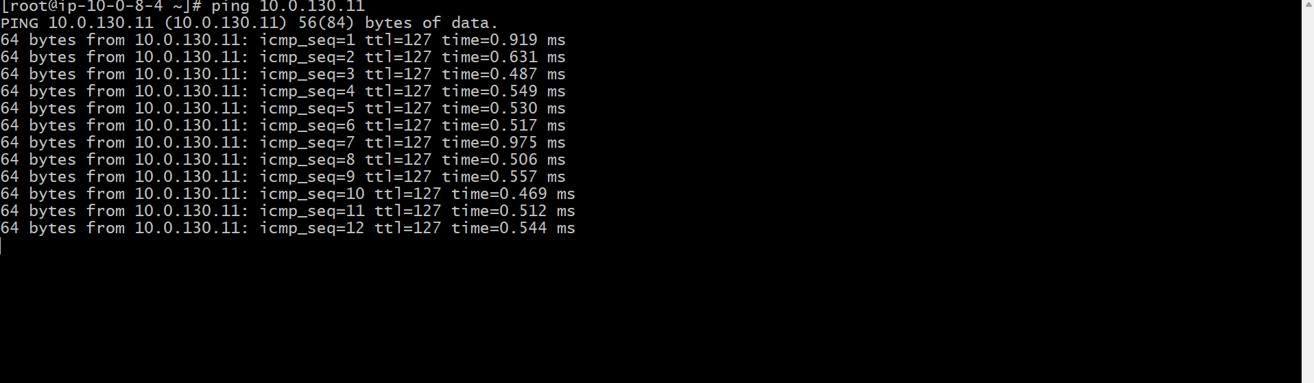

Successfully connected.

**3.db-tier**

create the db subnet group.

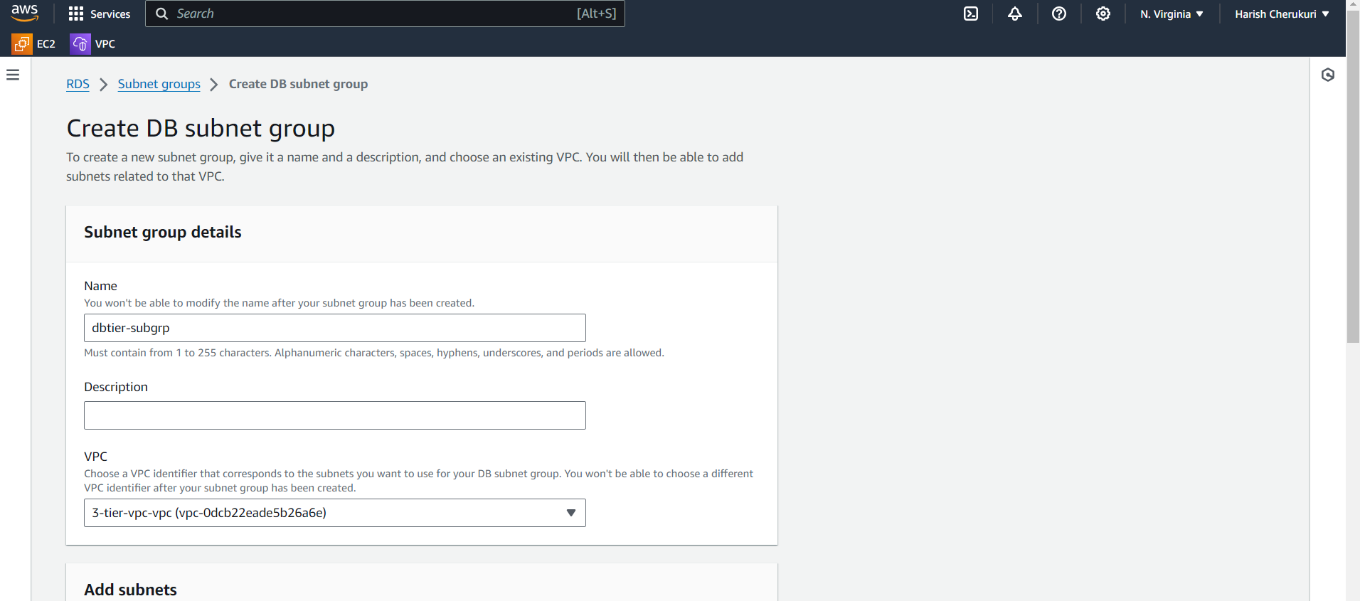

Give the subnet group

Select the vpc, az, and subnets.

Click on create .

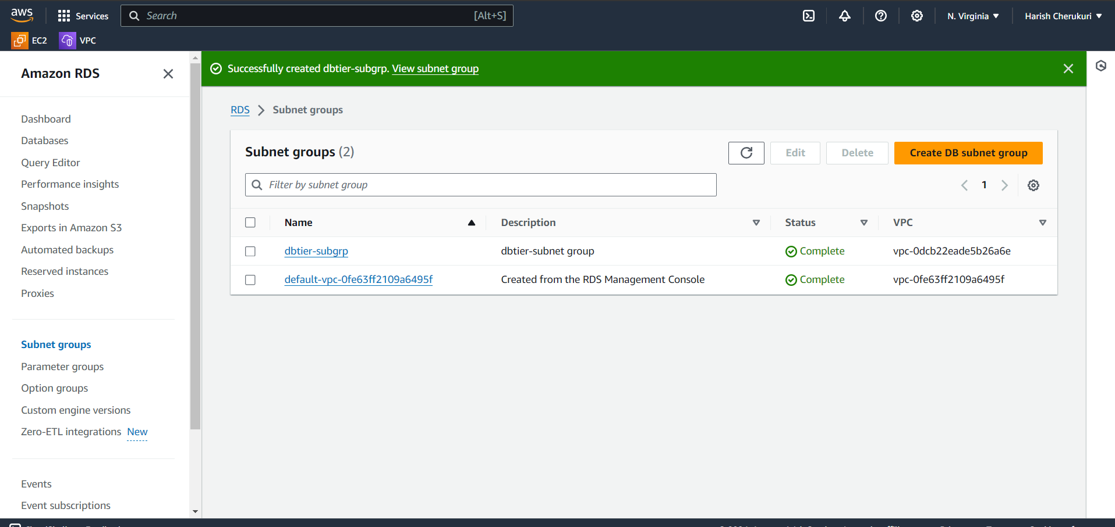

Subnet group is created.

Now create the db.

Select the standard , select mysql, free-tier, 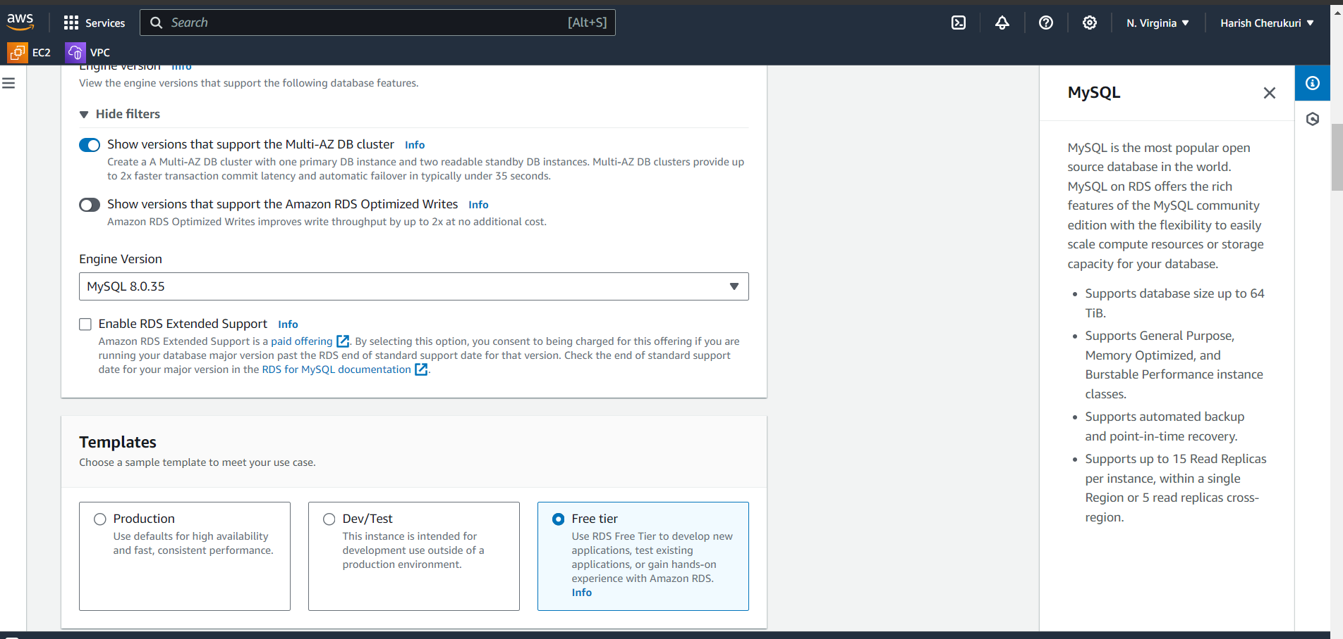

Give db name , select the self managed password.

Enter the password.

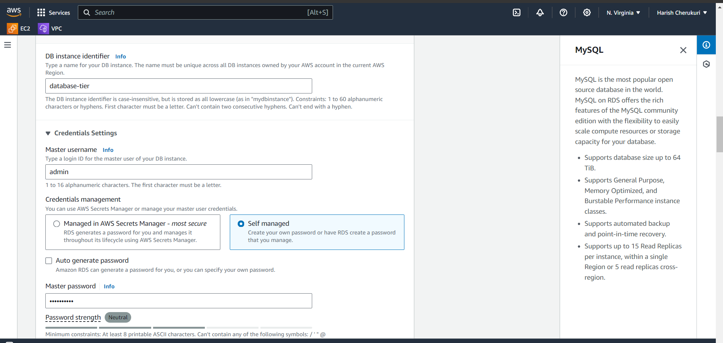

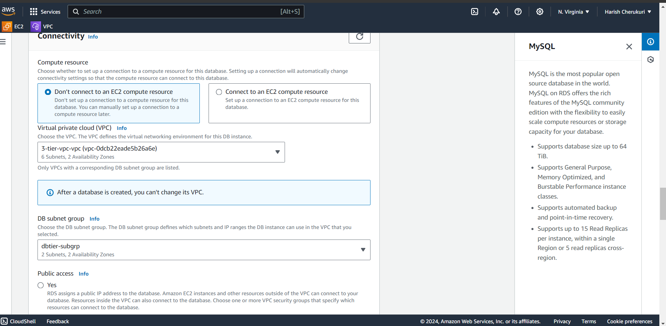

Select vpc and subnet groups.

Select public acess as no.

Create new security group.

Click on create db.

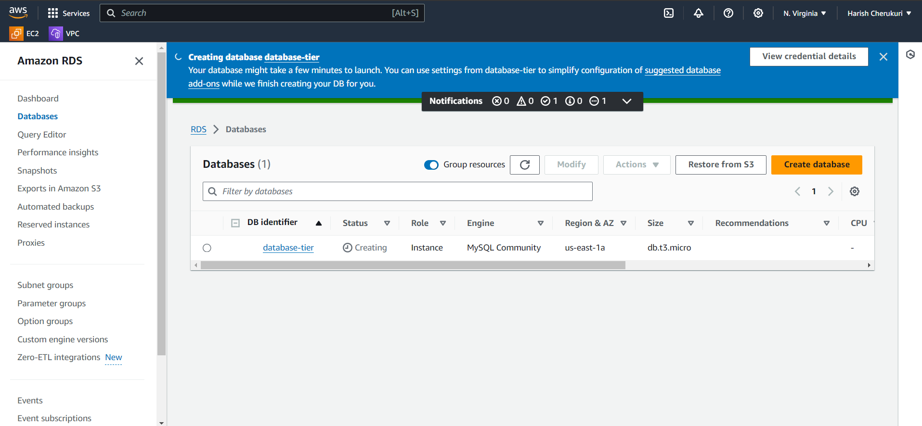

Db is created now go to security group of db-sg add mysql rule.

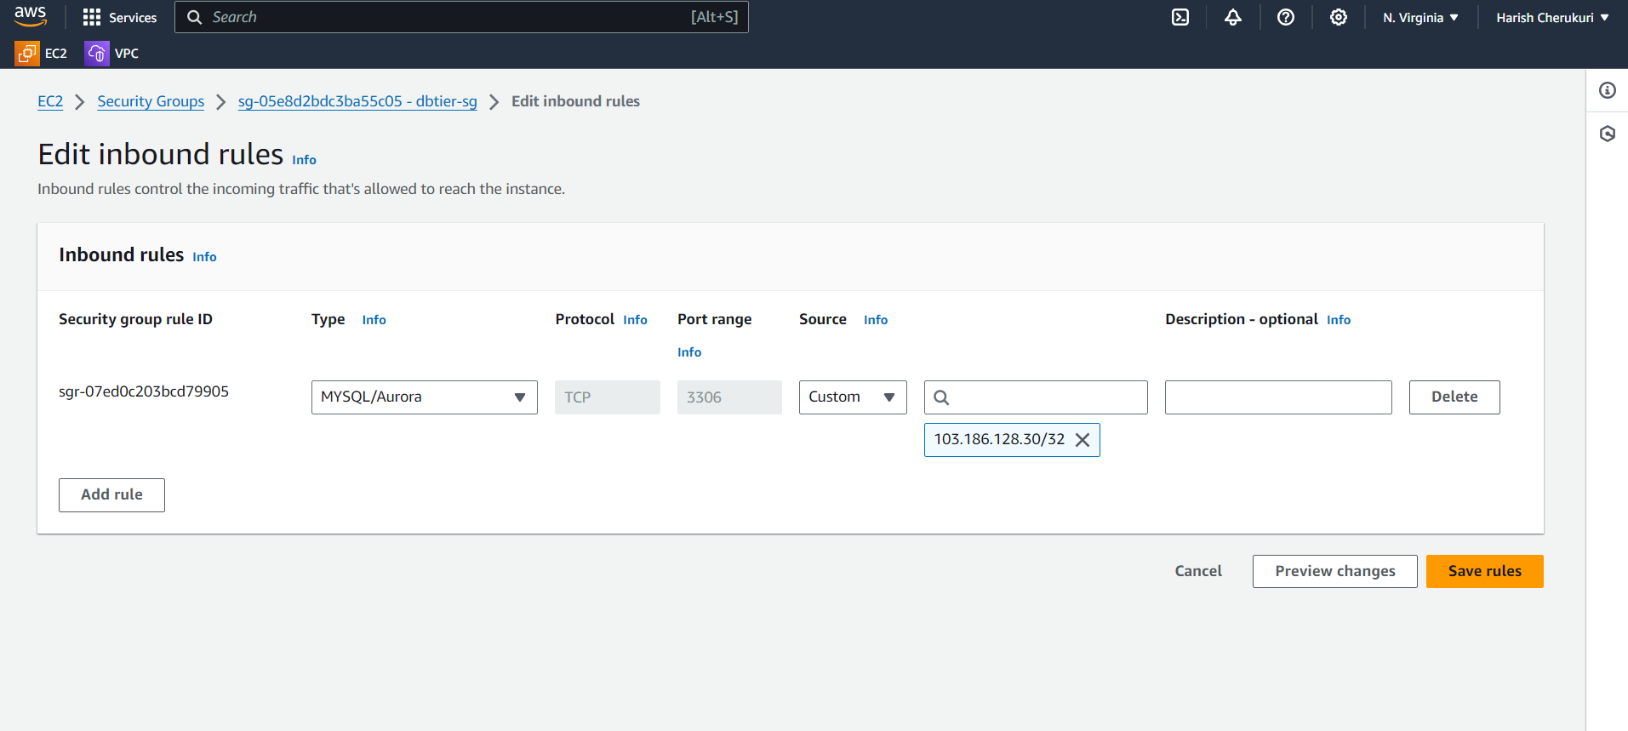

Now connect to first ec2 instance using ssh ,after connected install mysql in it.

After run mysql -h DNS of db -u admin -p

Enter the password.

You will connect to db.

